ED KIIRU

ETL PROCESS

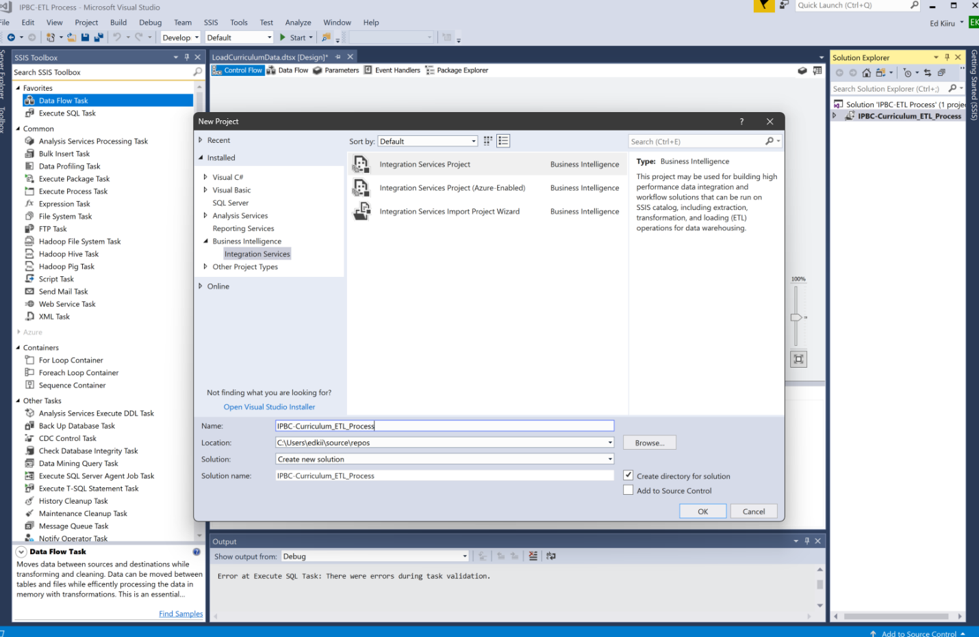

Opened Visual Studio And started a new integration service project called IPBC Curriculum_ETL_Process

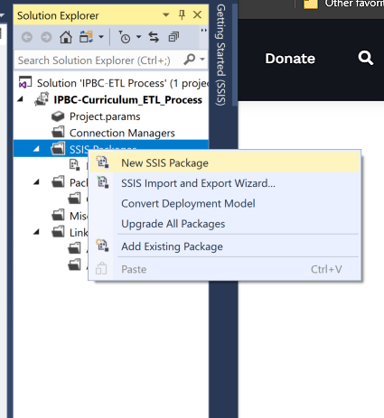

Started a new SSIS Package called LoadCurriclumumdata

Created a control flow to load the Excel workbook sheet to Course and load it to the curriculum database. Used an Execute SQL task for a truncated SQL Script as the first task.

Execute SQL settings for the truncate task

I created a data flow task named Load Course. I added an Excel source transformation which fetched the Excel files and an OLE DB Destination to load to the destination tables—also created the Excel connection Manager to fetch the file to the source transformation.

Excel Source editor settings

Replicated the same data flows and tasks for the other 2 Excel sheets

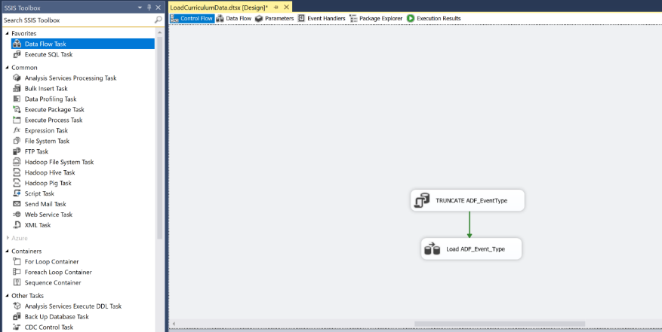

Created a new Control flow using an Execute SQL Task to run a truncate task on table ADF_EventType and connected it to a Data Flow called Load ADF_EventType

Run the ETL-Diagram SQL script in the SQL server verify it's ok, and create a new temporary database, called Master_curriculum.

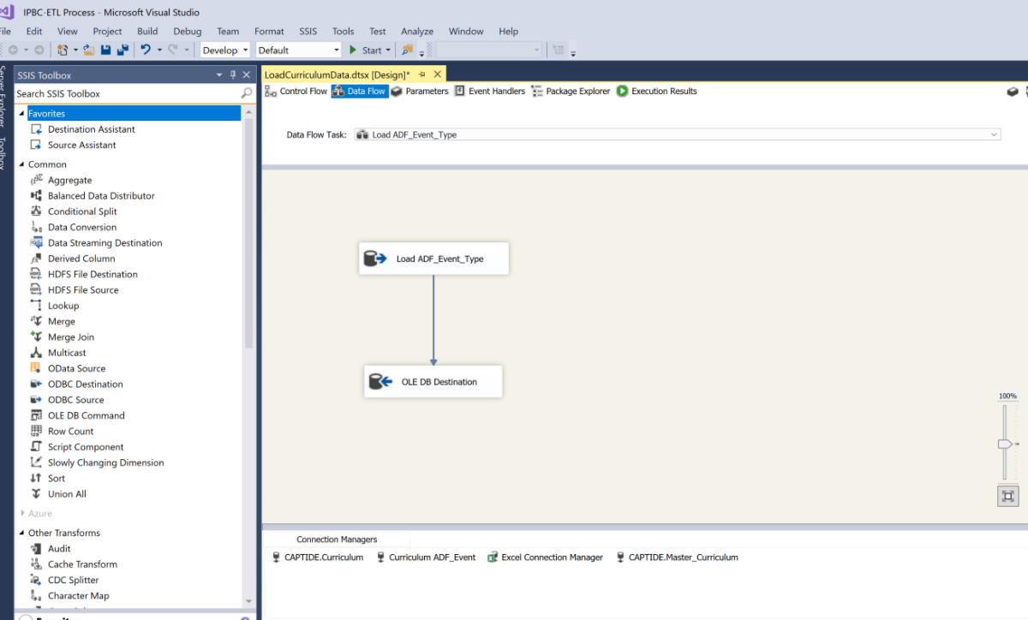

In the Dataflow I used OLE DB Source Transformation to load data from the ADF_EventType table from Master_Curriculum. Configured and connected it to the OLE DB Destination Transformation loading the files to the ADF-EventType table in the Curriculum database. Created 2 new connection managers Captide: Curriculum and Captide: Master_curriculum

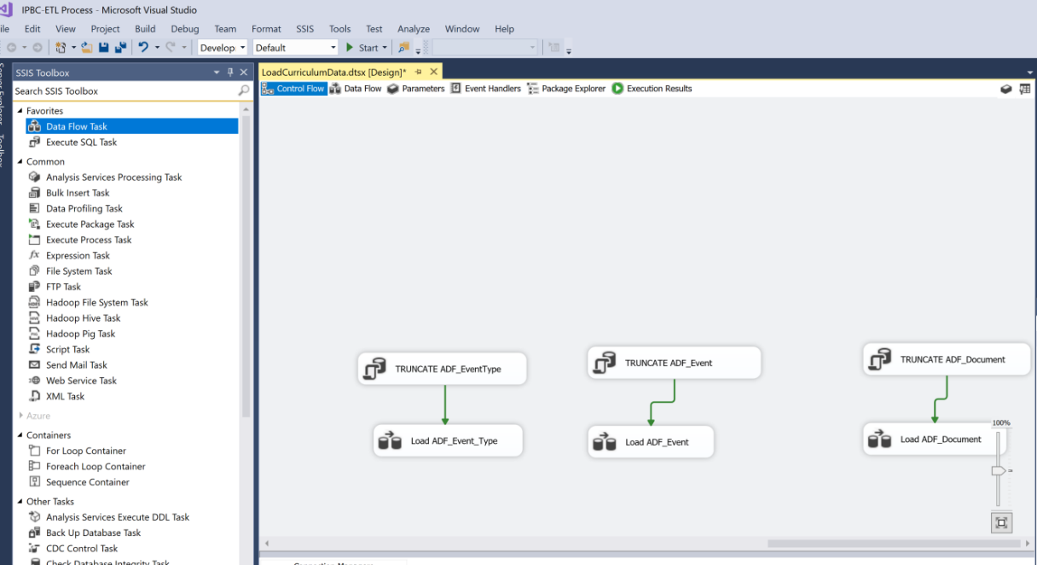

Replicated the same setup above to the other 2 tables from the ETL_Diagram SQL script loading them to ADF_Events and ADF_Documents Tables in the curriculum database

Executed the whole package and verified all the processes run and loaded data to the Curriculum table. Repeated 3 times with successful replication.

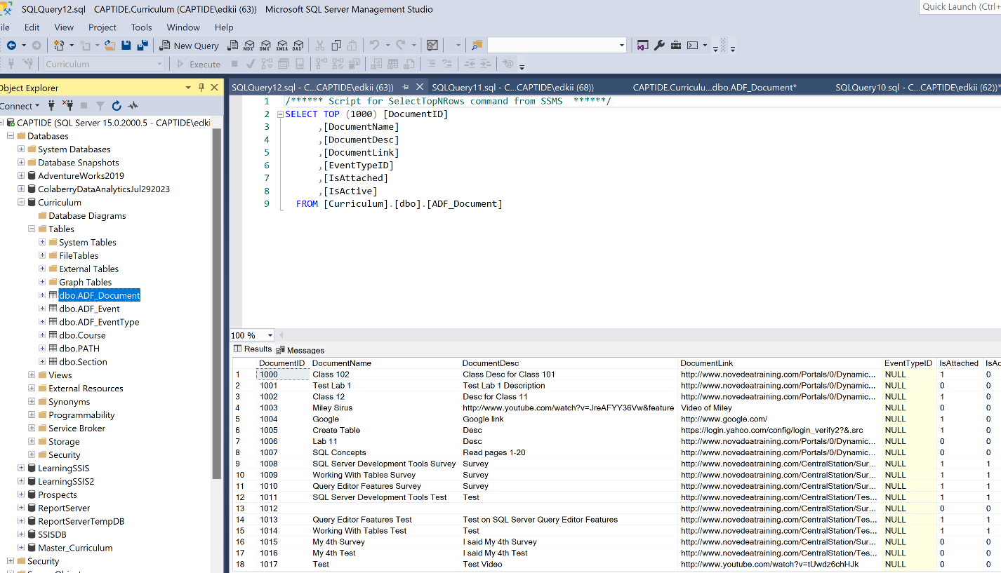

The curriculum database has six tables which are updated every time the package is executed